Hate Speech Detection Using Machine Learning

Submitted By-
Bikash Deka
Table of Contents
1.Executive Summary …………………………………………………………………………………….3
1.1 Project Overview ……………………………………………………………………………………3
1.2 Purpose and Scope of this specification …………………………………………………3
2.Product/Service Description ……………………………………………………………………..3
2.1 User characteristics ……………………………………………………………………………….3
2.2 Assumption …………………………………………………………………………………………..4
2.3 Constraints ……………………………………………………………………………………………4
2.4 Dependencies ……………………………………………………………………………………….4
3. Requirements …………………………………………………………………………………………..5
3.1 Functional Requirements ………………………………………………………………………7
3.2 User Interface Requirements …………………………………………………………………7
3.3 Usability …………………………………………………………………………………………………9
3.4 Performance ………………………………………………………………………………………….9
3.4.1 Capacity ……………………………………………………………………………………….10
3.4.2 Availability ……………………………………………………………………………………10
3.4.3 Latency …………………………………………………………………………………………10
3.5 Manageability/Maintainability ………………………………………………………………10
3.5.1 Monitoring …………………………………………………………………………………..10
3.5.2 Maintenance ………………………………………………………………………………..11
3.5.3 Operations ……………………………………………………………………………………11
3.6 System Interface/Integration …………………………………………………………………11
3.7 Data Management …………………………………………………………………………………13
4.User Scenarios/Use cases …………………………………………………………………………..13
Appendix A. References………………………………………………………………………………..15

Hate Speech Detection using Machine Learning
1. Executive Summary
1.1 Project Overview
Hate Speech toward people of particular or religion is spreading in social media, this online hatred can lead to real life consequences such as fear and hate throughout communities. Hate speech detection is important because it can help prevent these harmful effects.
Machine learning algorithms can be used to detect hate speech. These algorithms can analyze text and identify hate speech. They can also be used to determine the tone of a text. This can be used to identify hate speech that is disguised as jokes or sarcasm.
1.2 Purpose and Scope of this Specification
Hate speech generally come from social network domain because mostly people put up hate speech comments on certain social networks, and that I will try to resolve in this project.
This is a dataset of tweets and contains like 67000 tweets. 3380 are labelled as sexist and racist and 10000 also are neutral. The scope of this projects includes what are the different forms of hate they talk about and what is a basic social network and from where the dataset has been extracted.
https://paperswithcode.com/sota/hate-speech-detection-on-waseem-et-al-2018
2. Product/Service Description
Machine leaning is a type of artificial intelligence that can be used to learn from data. It can be used to find patterns in data. Machine learning algorithms can be used to detect the speech. These algorithms can analyze text and identify hate speech. They can also used to determine the tone of a text. Automated hate speech detection is an important tool in combating the spread of hate speech in social media.
The techniques for detecting hate speech suing machine learning include classifiers, deep learning. It can be used to find patterns in data. Natural Language processing techniques can be used to detect hate speech.
2.1 User characteristics
Student can used to learn how to algorithm is working behind and create their own machine learning algorithms to further classify and detect hate speech. Faculty/Staff members can further enhance the existing algorithms or create their own models which will lead to classify hate speech and detect hate speech.
Cyber Security experts can use such algorithms or models to detect and identify those people spreading hatred and take over their accounts, ban from social sites and if most severe take them into custody.
Game Developers can use these algorithms to target such account spreading toxic comments during the game and ban them or putting restrictions over their accounts.

2.2 Assumptions
Should have knowledge or blacklist kind of stuff, collection of such dataset from www.noswearing.com.
Hate verb lists.
Hateful terms and phrases for hate speech based on race, disability and so on from different web pages and sites.
Abbreviations and variants of those words.
These are some kinds of dictionaries which one can use so as to essentially rule based systems to detect hate speech very quickly in an efficient manner.
2.3 Constraints
Datasets needs to be collected to train and test the model to predict and detect the hate speech.
Number of characters, words, and syllables in each sentence when it comes to detect hate speech.
Abbreviations need to be identified properly.
English level score is used such as if sentence looks much more formal then there is low probability of it being hate speech.
Some websites present extremely antisemitic ideologies and conclusions in a very scientific manner, there we can say it will be objectively presented things on hate speech.
2.4 Dependencies
Datasets – any form of dataset is required to analyze the data without data no evaluation can be done thus no result will be there.
Dictionaries – content words and n-grams
Bag of words
N-grams: word and character
Word embeddings: Distribution of bag of words.
Tools such as word2vec, glove, fastext
TF-IDF, Part-of-speech, NER, dependency parsing

3. Requirements
1. Datasets.
Collection of data from various sources such as twitter, Instagram, websites.
Popular social network datasets such as
1. Twitter: Waseem et al.2018
2. Twitter: Wijesiriwardene et al. 2020
3. Davidson et al. 2017
2.Feature engineering.
Important features are extracted from the dataset to analyze the most predictable outcome from the dataset.
3.Topic classification.
Using LDA (linear discriminant analysis) the most popular topic modelling technique right topics could be used as features.
4.Sentiment Analysis/classification.
Identifying opinions in text and labelling them as positive, negative, or neutral based on the emotions users express over the sites.
5.Classification
Frequency of personal pronouns, presence of emoticons.
6.Flesh reading escores.
Measure how correctly the grammar is used in the sentence.
7. Have some word embeddings or words being represented.
Using distributed representations of words to learn their vectorized representation which are used in text mining operations.
8.Deep learning
Traditional approaches like TF-IDF, recently developed word embedding. Convolutional neural networks (CNN), Long-Short term memory (LSTM) are three most popular deep neural network designs used for hate speech detection using deep learning models.

9.Packages such as NumPy, pandas, matplotlib, pyplot, Wordcloud, sklearn.
10.NLP tools: re, nltk.
11.Leveraging metadata.
12.Data Augmentation.
13.Handling Bias.
14.Multilabel classification.
15.Classifiers/Regressors –
SVMs
Logistic regression
Random forests MLPs
Naïve Bayes.
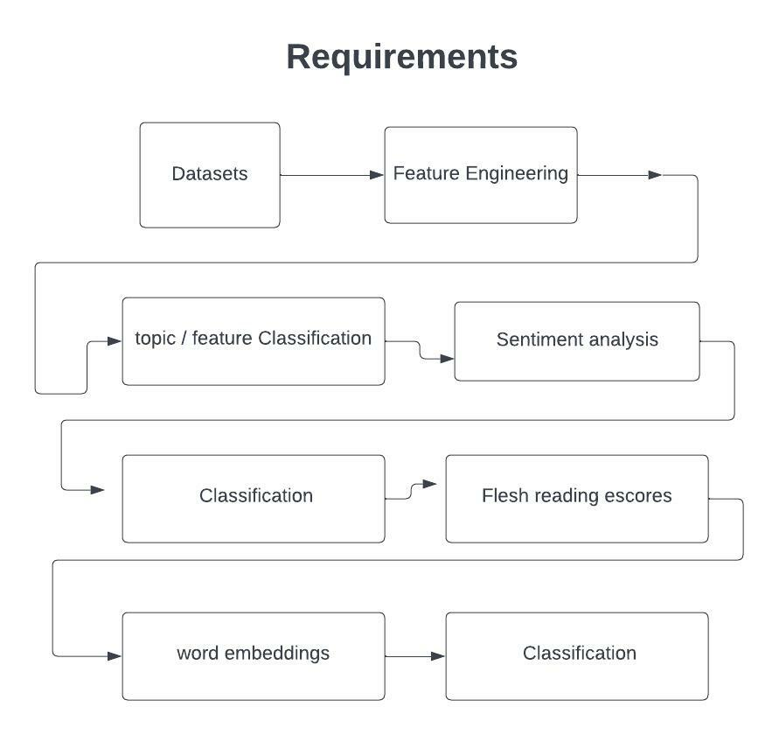

3.1 Functional Requirements
Datasets
Dictionaries
Bag of words
N-grams: word and character
Word embeddings.
Tools such as word2vec, glove, fastext
TF-IDF, Part-of-speech, NER, dependency parsing
NumPy, pandas, wordcloud, matplotlib, sklearn, re, nltk
RandomForesetClassifier
LogisticRegression
KNeighborsClassifier
DecisionTreeClassifier
3.2 User Interface Requirements
In order to create a hate speech detecting algorithm, I am going to use python based NLP machine learning techniques. Machine learning is basically teaching machines to accomplish various tasks by training them through data.
First collection of data is important, can get the data from anywhere and import it over the platform.
Then using a NLP (Natural language Processing) technique called Tf-Idf vectorization, I will extract keywords that convey importance within hate speech. This process is done by assigning Tf-idf scores to each word in a document.
Converting texts into numbers so the algorithm can understand it. By focusing on the words that convey importance, extract keywords from documents in order to understand it.
Finally, based on machine learning technique called logistic regression, I will train the algorithm to classify hate speech using the data extracted, however machine learning algorithms that can be used to detect hate speech include Naïve Bayes, Support Vector machines, extreme gradient boosting, multi-layer perception, long – short term memory networks.
In order to train the classifier, the data needs to be converted into its vector representation. The vectors representation can be generated using different methods such as bag of words, Tf-idf, and word embeddings. With the progress in deep learning based embeddings, tools such as word2vec, glove, fasttext, and transform based methods can be applied to obtain more expressive representations.
Import libraries required for solving and in detection of hate speech.
Import tools for Natural Language Processing.
Import models for the dataset.
Import the dataset that is required for analysis.
Split the data into train/test dataset.
Some preprocessing required in the dataset.
Finally applying the model and drawing a confusion matrix out of it.
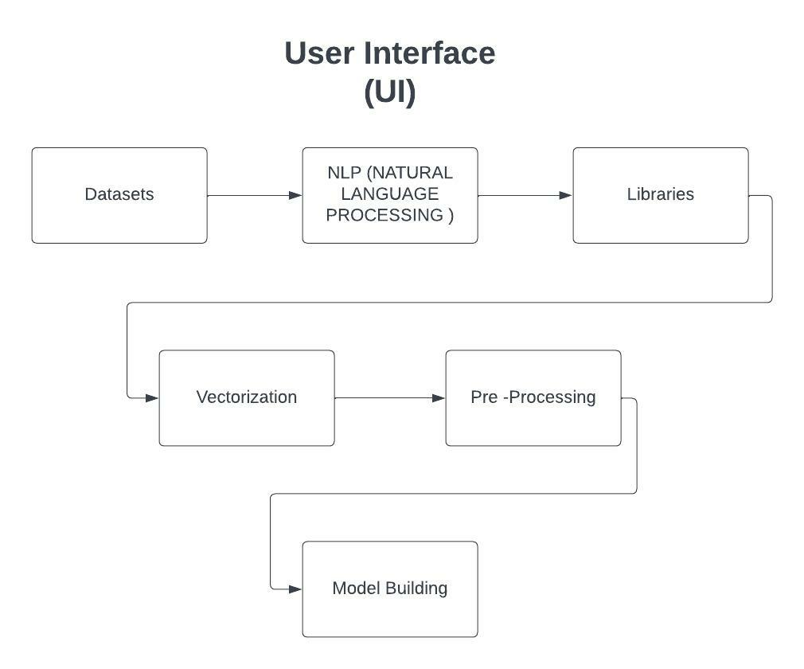

3.3 Usability
For better understanding and usability, the data we are using should be labeled appropriately.
Features of Natural Language Processing such as
Dictionaries
Bag of words
Ngrams
Tf-idf, part of speech, NER, dependency parsing
Word embeddings
Topic classification
Sentiment analysis
Frequencies of personal pronouns
Presence of emoticons, capital letters
Flesh reading escore.

3.4 Performance
The hate speech detection datasets are usually not clean, so they need to be preprocessed before classification algorithms can be applied and that can detect hate speech in them.
Different machine learning models have different strengths that make some algorithms better than others for certain tasks such as detecting hate speech. Some models are more accurate while others are more efficient.
It is important to use different models and compare their performance in order to find the best one for hate speech detection. Pre training models have become popular in recent times and it is important to test whether they work well with hate speech detection algorithms.
It is also important to see how hate speech detection models can be used to address domain changes.

3.4.1 Capacity
I tried to identify and examine challenges faced by online approaches for hate speech detection in text. Among these difficulties are subtitles in language, differing definitions, limitations of data availability for training and testing of these systems.
Due to wide spread of hate speech over the internet there is a need to study automatic detection of hate speech. By automating its detection, the spread of hateful content can be reduced.
3.4.2 Availability
This algorithms and model can be used individually or can be deployed over the servers to detect the hate speech in social media, websites, online games while sending texts or messages. The algorithms and models run over the servers all the time and should be available to stay away from the toxic and hateful speech.
The impact of downtime of these models can lead to many unfortunate events and can lead to catastrophic failures of the administration, people spreading hatred will spread more hateful comments thus impacting the individuals or groups who try to avoid from such events.
The models are further available with criminal investigation proceedings officer to investigate more severe cases in analyzing the texts which are already prebuilt into the systems of the authorized personnel.
Further this algorithm can also be used by the students/researchers to analyze and study the traditional approaches and can develop their own models with better efficiency and better efficiency.
3.4.3 Latency
The algorithms or models deployed over the internet can face latency or during the online games player may face latency thus resulting in no real time working of these models, however if such algorithms or models are present with individuals than there is no subject to latency, as they can be directly used by providing the necessary inputs to the model and deploying it and get the results out of it.
3.5 Manageability/Maintainability
3.5.1 Monitoring
For requirement purpose it is very important to have dataset from various sources in order to train and test the algorithms.
Features of Natural Language Processing such as
Dictionaries
Bag of words
Ngrams
Tf-idf, part of speech, NER, dependency parsing
Word embeddings
Topic classification
Sentiment analysis
Frequencies of personal pronouns
Presence of emoticons, capital letters
Flesh reading escore.
3.5.2 Maintenance
The algorithms or the models need to be modified or changed in accordance with the time in order to provide high reliability on the system, provide real time results, update the word cloud, bag of words, word embeddings, sentiment analysis should be done to classify the results so they need to be preprocessed before classification algorithms can be applied and that can detect hate speech in them.
3.5.3 Operations
User definitely need to collect data for the training of automatic classifiers to detect hate speech for that some necessary operations need to be performed.
The data needs to be converted into its vector representation. The vectors representation can be generated using different methods such as bag of words, tf-idf, word embeddings.
With the progress in deep learning based embeddings, tools such as word2vec, glove, fasttext, methods have to be applied to obtain more expressive representations.
Tf-idf vectorization will extract keywords that convey importance within hate speech.
So that finally machine learning technique called logistic regression, will train the algorithm or model to classify hate speech using the data extracted from the dataset after preprocessing.
3.6 System Interface/Integration
Database of datasets are required that identify hateful, aggressive, and insulting texts. A representative sampling of available training and evaluation public datasets need to be collected.
Several databases are-
Hate base Twitter
WaseemA, WaseemB
Stormfront
From these datasets the data needs to be converted into its vector representation. The vectors representation can be generated using different methods.
Deep learning is a type of machine learning that can be used to learn from data. It can be used to find patterns in data. Machine learning algorithms can be used to detect hate speech.
These algorithms can analyze text and identify hare speech. They can also be used to determine the tone of a text. This can be used to identify hate speech that is than being classified has hate speech or not.
Automated hate speech detection is an important tool in combating the spread of hate speech, in social media sites, online gaming or websites.
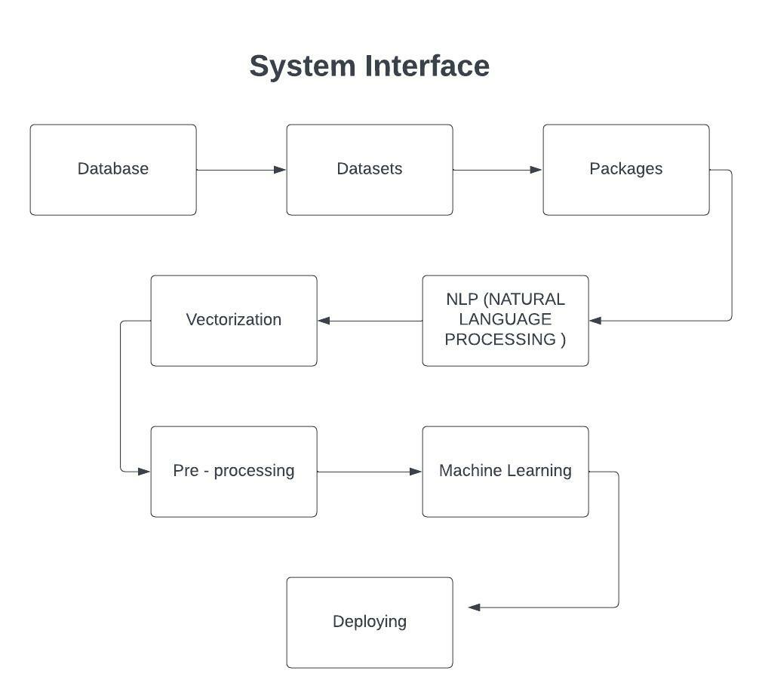
3.7 Data Management
Examine existing definitions to gain insights into what is hate speech and technical challenges to know the definitions. I will here bring leading definitions of hate speech from varying sources, as well some aspects of the definition that make the detection of hate speech.
Features of Natural Language Processing are used
Dictionaries
Bag of words
Ngrams
Tf-idf, part of speech, NER, dependency parsing
Word embeddings
Topic classification
Sentiment analysis
Frequencies of personal pronouns
Presence of emoticons, capital letters
Flesh reading escore.
These factors are to be considered while we are processing the data to use the training and testing data sets in the deployment of the model.

4. User Scenarios/ Use Cases
1.Twitter
As hate speech continues to be a problem, the need for automatic hate speech detection systems become more important. The algorithms and models are used for detection of hate speech and offensive language on twitter through machine learning.
2.Facebook
Facebook have recently developed a new transformer architecture called linformer. It makes it possible to use them efficiently at scale. This makes it possible to use larger pieces of text to train models and thereby achieve better performance.

3.Instagram
Instagram have a number of tools that help people protect themselves. People can use comment filters to prevent others from leaving offensive comments that use words, phrases or emojis they do not want to see.
4.Gaming platforms
Hate speech and toxic comments in the chats are very common among the youths which they pass on among each other during a round or match of a game. These needs to be controlled or tackled effectively in order to maintain a healthy environment among the players of each side. These machine learning algorithms and models can be deployed to tackle the toxicity of comments and control the hate speech.
5.Websites
Hate speech is an important problem, websites that allows users to leave feedback, having negative impact on their online business and overall user experience. Now these algorithms or models can be deployed and can be triggered whenever there will be hated speech thus leading to removal of those comments or the feedback or strict action against those accounts.

Appendix A. References
https://vitalflux.com/hate-speech-detection-using-machine-learning/
https://towardsdatascience.com/my-first-machine-learning-project-designing-a-hate-speech-detecting-algorithm-56ab32f10833
https://www.analyticsvidhya.com/blog/2022/02/classifying-sexual-harassment-using-machine-learning/
https://www.analyticsvidhya.com/blog/2022/07/predicting-the-toxicity-of-comments-using-text-classification/
https://journals.plos.org/plosone/article?id=10.1371/journal.pone.0221152
https://arxiv.org/pdf/1803.03662.pdf
https://towardsdatascience.com/detecting-hate-tweets-twitter-sentiment-analysis-780d8a82d4f6
https://ai.facebook.com/blog/how-facebook-uses-super-efficient-ai-models-to-detect-hate-speech/
https://about.instagram.com/blog/announcements/an-update-on-our-work-to-tackle-abuse-on-instagram
https://dl.acm.org/doi/abs/10.1145/2740908.2742760

